Oberon Ilano

CS 447

Lab #11

**1.**

DELIMITER |

CREATE FUNCTION getBundle (p int)

RETURNS varchar(16) DETERMINISTIC

BEGIN

IF (EXISTS(SELECT PC.model, Printer.model FROM PC, Printer

WHERE PC.price + Printer.price <= p))

THEN RETURN 'TRUE';

ELSEIF(EXISTS(SELECT Laptop.model, Printer.model FROM Laptop, Printer

WHERE Laptop.price + Printer.price <= p))

THEN RETURN 'TRUE';

ELSEIF(EXISTS(SELECT PC.model, Printer.model FROM PC, Printer

WHERE PC.price + Printer.price > p))

THEN RETURN 'FALSE';

END IF;

END;|

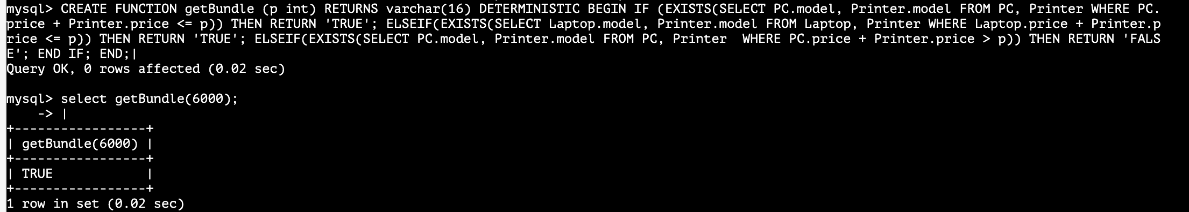

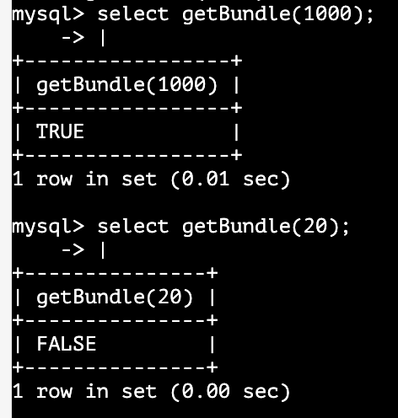

**2.**

DELIMITER |

CREATE FUNCTION getPrice(ma char, mo int)

RETURNS int DETERMINISTIC

BEGIN

DECLARE p int;

IF(EXISTS(SELECT type FROM Product

WHERE Product.manufacturer = ma AND Product.model = mo AND Product.type = 'pc'))

THEN SET p = (SELECT price FROM PC WHERE PC.model = mo);

ELSEIF(EXISTS(SELECT type FROM Product

WHERE Product.manufacturer = ma AND Product.model = mo AND Product.type = 'laptop'))

THEN SET p = (SELECT price FROM Laptop WHERE Laptop.model = mo);

ELSEIF(EXISTS(SELECT type FROM Product

WHERE Product.manufacturer = ma AND Product.model = mo AND Product.type = 'printer'))

THEN SET p = (SELECT price FROM Printer WHERE Printer.model = mo);

END IF;

RETURN p;

END; |

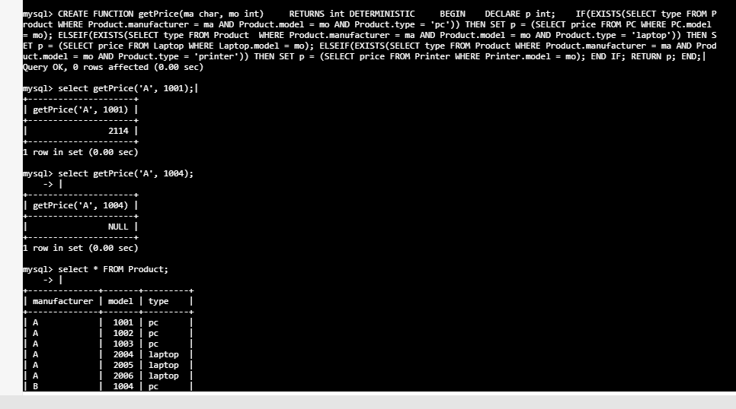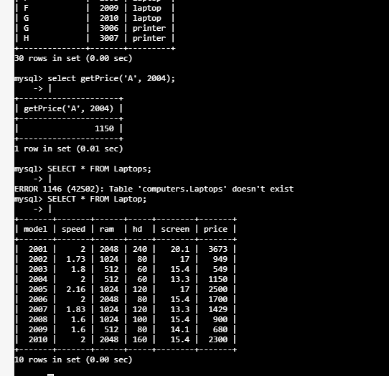

**3.**  
DELIMITER |  
CREATE FUNCTION getPCprice(p int)   
RETURNS int DETERMINISTIC    
BEGIN   
DECLARE s int;

SET s = (SELECT DISTINCT model FROM PC GROUP BY ABS(price - p) LIMIT 1);  
RETURN s;   
END; |

